Use Case Realisation Report - Manage ProjectGENERATE REPORT
FOR
Volunteer Management System
(VMS)

CLIENT
PROJECT | Volunteer Management System (VMS)
TITLE | Use Case Realisation Report - Manage ProjectReport
VERSION | 0.1a
DATE | 13-Aug-2011
 | ORIGINATOR
 | Name / Signature | Team 8S
 | APPROVAL
 | Name / Signature | Phung Kim Cuong, Dio
Institute of Systems Science |  | Document Reference
25 Heng Mui Keng Terrence  Singapore 119615 |  | VMS/PM-1.3.1/1

 | Acceptance
 | Customer Signature |  | Customer Signature
 | Name & Designation |  | Name & Designation
 | Date & Company Stamp |  | Date & Company Stamp

Revision History

Date | Version | Description | Author
12-Jun-2011 | 0.1a | Creation | Team 8S
 |  | Refer to amendment history

Table of Contents

Use Case Realisation Report - Generate Report 3
1. Brief Description 3
2. Flow of Events 3
2.1 Standard Flow 3
2.2 Exceptions 3
3. Interaction Diagrams 4
3.1 Generate Report 4
4. Participating Objects 4
5. Class Diagrams 4
6. Derived Requirements 4
ANNEX D Amendment History 5

Use Case Realisation Report - Manage ProjectGenerate Report

Brief Description
This use case allows the batch scheduler to generate reports based on predefined schedule.

Flow of Events
The standard flow of events for this use case and any exceptions are described in the following subsections. See section 3.1 for an overview of the participating Actors and Domain Objects.

Standard Flow
This use case provides the functionality that will be provided to the batch scheduler as follows:
- When the user clicks ‘Generate Report’ button, the method MainController .getReportScreen() is triggered.
- The MainController.getReportScreen () will use the method ReportController.getReport() to get the report.
- ReportController.getReport () will use the ReportData.getReportData() method to get Report data.
- The printReport screen will show, and get report data for printing.
- The use case terminates

Exceptions
The following exceptions were identified:

Interaction Diagrams

Generate Report

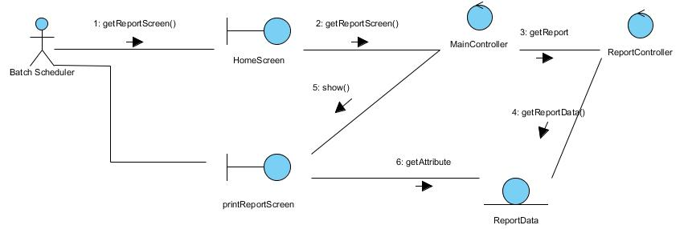

Participating Objects

Class Diagrams
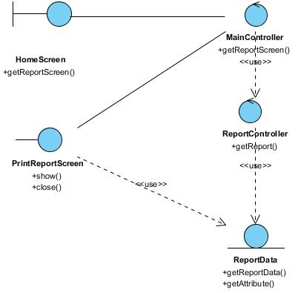

Derived Requirements

ANNEX D Amendment History

This is a record of all amendments made to the Document.
Version | Chapter / Section | Page No | Notes of Amendments or Changes

